**POWER BI ASSIGNMENT-8**

**Use Case** - Product information

**Source** – Incomplete Report

**Analytic** – Fill in three time intelligence functions in a report.

Q1. Create 3 Measure using the table – the screen shot below shows what this should show. Here are the measures you need to create:

**Step-1:** The data set for this assignment was not available whereas the actual PowerBi file was available and the request was to modify the pbix file based on the above guidelines. The PowerBi file was names as “Incomplete report.pbix”.

The actual pbix file was opened where it contained few report and the task is to modify 3 measures. The screenshot of the report is shown below

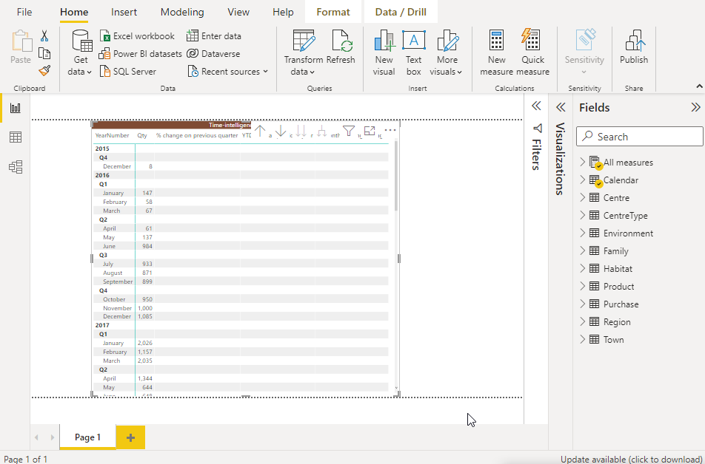

The measure was already created and it has been modified based on the below DAX Formulas.

1. % of previous quarter

**Step-2.** % change on previous quarter =

DIVIDE([Qty],CALCULATE([Qty],PARALLELPERIOD(‘Calendar’[DateKey],-3,MONTH)))

1. YTD % of all previous year

**Step-3**. YTD % of all previous year =

DIVIDE(TOTALYTD(SUM(Purchase[Quantity]),’Calender’[DateKey]),CALCULATE(SUM(Purchase[Quantity]),PARALLELPERIOD(‘Calendar’[DateKey],-1,YEAR)))

1. 3-month moving average

**Step-4.** 3-month moving average =

CALCULATE(SUM(Purchase[Quantity])/3,DATESINPERIOD(‘Calender’[DateKey],LASTDATE(‘Calender’[DateKey]),-3,MONTH))

Once the respective measures has been modified, the data gets reflected into the report and is shown below

